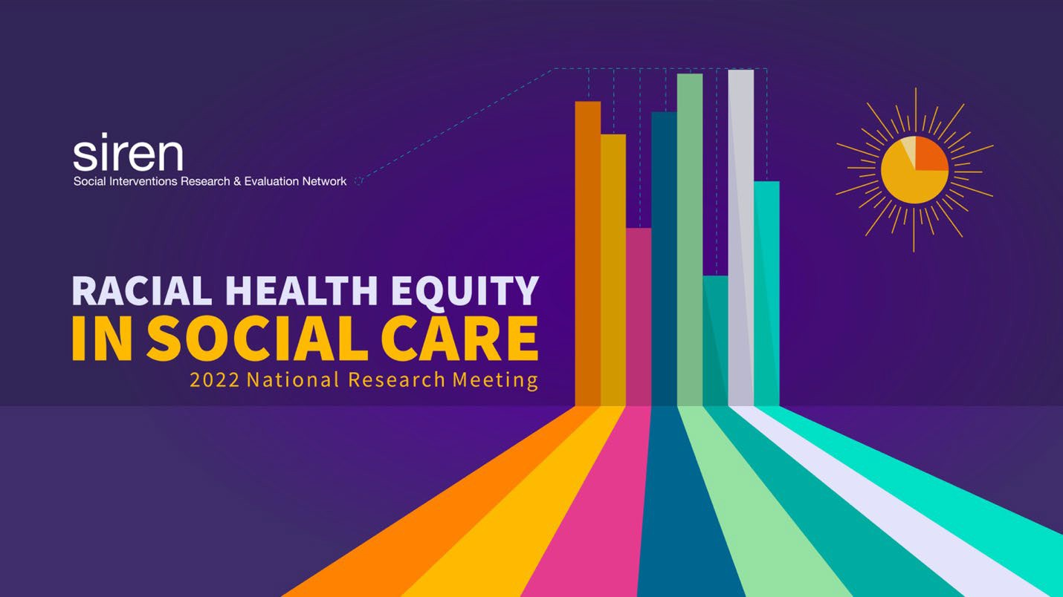

SIREN 2022 National Research Meeting:
Racial Health Equity in Social Care

MEETING AGENDA

Click below on one of the dates or times to jump to the corresponding section of the agenda:

Day 1 (September 15, 2022)  9-10am: Plenary  10-11am: Concurrent sessions 11am-12pm: Concurrent sessions 12-12:10pm: Mindfulness | Day 2 (September 27, 2022)  8:30-9am: Community time 9-10am: Plenary  10-11am: Concurrent sessions 11-12pm: Concurrent sessions  12-12:10pm: Mindfulness | Day 3 (October 12, 2022)  9-10am: Un-plenary  10-11am: Concurrent sessions 11-12pm: Plenary

For more information, visit the SIREN website: https://sirenetwork.ucsf.edu/

Day 1

Plenary

What can we learn from abolition work in other sectors?
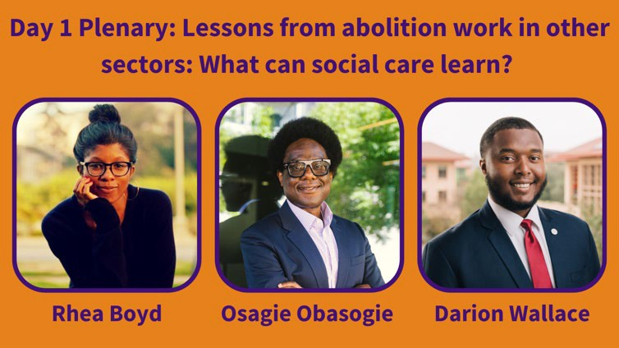
Speakers: Rhea Boyd (pediatrician, public health advocate, and scholar; multiple affiliations), Osagie Obasogie (School of Law, Joint Medical Program, School of Public Health at University of California, Berkeley), Darion Wallace (Stanford Graduate School of Education)

Description:
Social care practice and research are often inspired by intentions to advance health equity. However, social care is often planned and executed without a clear recognition of and confrontation with the racism, particularly anti-Black racism, that has led to existing inequities. While the legally-sanctioned enslavement of Black people in the United States was abolished in 1865, many of its aims have been perpetuated through residential segregation, the War on Drugs, and the school-to-prison pipeline, to name a few examples. The SIREN National Research Meeting kicks off with a challenge to our moral imagination: In what ways would social care benefit from the contemporary theory and practice of abolition movements in other sectors? Physician, scholar, and thought
leader Rhea Boyd will facilitate a discussion with legal professor and ethicist Osagie Obasogie and education scholar Darion Wallace. Discussants will explore how abolitionist thinking has been applied in other fields, including the legal system and school-based education and ways to re-imagine types of social care that cultivate healing and racial health equity. Participants will be able to ask questions of the panel using the Q&A function.

We ask that all participants review the Agreements for a Safe and Brave Meeting before joining this session.

Concurrent Sessions 10:10-11 AM Pacific

Challenges and strategies for evaluating racial equity in health initiatives
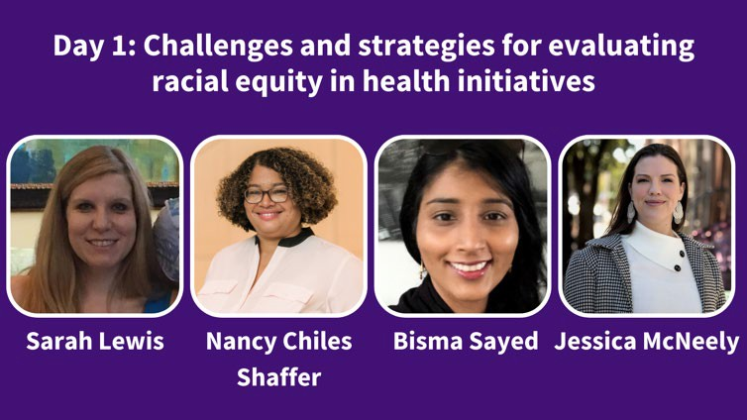
Speakers: Nancy Chiles Shaffer (Centers for Medicare and Medicaid Services Innovation Center (CMMI)), Sarah Lewis (CMMI), Bisma Sayed (Office of Health Policy, Department of Health and Human Services), Jessica McNeely (CMMI)

Description:
Though most Center for Medicare and Medicaid Innovation's (CMMI's) models have not targeted underserved populations, some have, and others offer opportunities for evaluations to investigate health equity related outcomes. Evaluations of models that aim to improve the health care of underserved populations and utilize health-related social needs screening offer baseline information about the state of equity in healthcare and lessons learned that can apply to developing future interventions. The majority of CMMI's underserved program enrollees receive Medicaid, the public health insurance program for low income children and adults. Models generally enroll Black beneficiaries in proportions similar to proportions in the populations served, though other disadvantaged racial and ethnic groups are more difficult to identify and measure. Models considered in this presentation utilize health-related social needs screening to identify beneficiary needs beyond clinical care with the intent of providing relevant resources to address or mitigate those needs.
Qualitative evaluations of lived experiences provide detailed insights regarding challenges faced by low-income and racial minority populations. This session will include a 25 minute presentation synthesizing health equity evaluation findings in CMMI models that enroll underserved populations and screen for health-related social needs, highlighting challenges and opportunities across sectors. Rigorous evaluations utilized a range of valid and appropriate qualitative and quantitative methods (e.g. focus groups, PhotoVoice, difference-in-differences analyses). Understanding equity-related gaps can provide a foundation for improving future models of care, addressing social care more effectively, and identifying opportunities and challenges for future research relating to social care. The presentation will also include a 25 minute discussion to encourage dialogue on and examination of the strategies and challenges for evaluating racial health equity in health initiatives.

Learning Objectives
- Identify the current state of racial health equity analyses in CMMI evaluations, included who our models have reached and what racial/ethnic groups are currently represented.
- Assess the main outcomes and any observed differences across racial/ethnic groups.

- Identify and interrogate the strategies and challenges for evaluating racial health equity in health initiatives.

Discrimination in health and social care
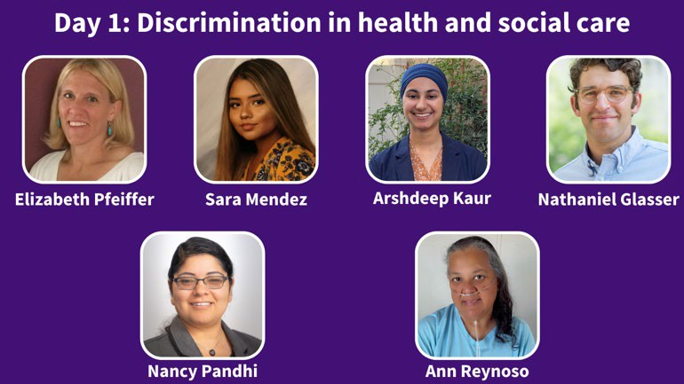
Speakers: Arshdeep Kaur (California University of Science and Medicine), Elizabeth Pfeiffer (Rhode Island College), Sara Mendez (Rhode Island College), Nathaniel Glasser (University of Chicago) Moderator: Nancy Pandhi (Department of Family and Community Medicine, University of New Mexico)
Discussant: Ann Reynoso (Patient Insight Institute; SIREN)

Description:
The presentations in this session will explore how patients who receive or could receive social care in healthcare settings experience discrimination in diverse settings, and how such experiences are linked to other aspects of patient experience and wellbeing. Moderated by Nancy Pandhi, with reflections by discussant Ann Reynoso.

- "Evaluating Associations between Patient/Caregiver Experiences of Healthcare Discrimination and Trust in Provider" by Arshdeep Kaur (California University of Science and Medicine)
Discrimination in healthcare settings is linked to lower trust in healthcare providers; a potential byproduct of social risk screening is helping providers strengthen relationships with patients and build trust. Social care programs must avoid (re)traumatizing patients through experiences of discrimination, and must work to build trust.

“Uncovering intersecting forms of discrimination during a social care program in a community health center in Rhode Island” by Elizabeth Pfeiffer and Sara Mendez (Rhode Island College)
This presentation will describe a qualitative research project that explored why it is that people decline social care assistance after they indicate that they have social needs in clinic settings. Prioritizing the perspectives and lived experiences of the patient participants interviewed during this study, we will highlight the key finding that intersecting forms of discrimination—across the lines of race and ethnicity, language, immigration status, and socioeconomic status—served as a barrier to patients’ accepting social care assistance.

“Impact of experiences of discrimination on self-efficacy among parents and other primary caregivers of hospitalized children” by Nathaniel Glasser (University of Chicago)

Parents who report more frequent experiences of discrimination during a child’s hospitalization are more likely to display lower self-confidence in their ability to find healthful community resources. While there are many possible explanations for the association, the finding is concerning given broad overlap between those who report experiencing discrimination and those with health related social-needs.

Equity-focused social care in practice
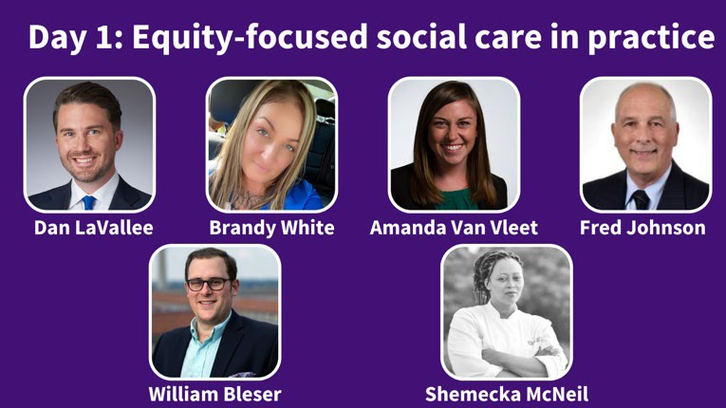
Speakers: Dan LaVallee (UPMC Center for Social Impact), Brandy White (Freedom House 2.0 graduate & UPMC), Amanda Van Vleet (North Carolina Department of Health and Human Services), Fred Johnson (DukeHealth), William Bleser (Duke University), Shemecka McNeil (Slice 325), Nameeta Mota (Patient Insight Institute; SIREN)

Description:
This session brings together two communities that are applying a racial health equity lens to on-the-ground social care programs, who will each offer lessons learned from multiple perspectives (e.g. health care, lived experience/participant, social services, researcher/evaluator) that attendees can apply to their own initiatives. Moderated by Expert by Experience Nameeta Mota.

- "Addressing work as a social determinant of health: one Medicaid plan's approach to partnership" by Dan LaVallee (UPMC Center for Social Impact) and Brandy White (Freedom House 2.0 graduate & UPMC)
This interactive presentation focuses on the dual health and economic impacts of the COVID-19 pandemic among marginalized groups, from the perspective an integrated payer-provider health care system and major employer. While these race-based disparities existed long before COVID-19 due to structural racism in health care and society, UPMC has leveraged our position to impact social wellbeing through a work-focused intervention portfolio called Pathways to Work, which is implemented with community-based partners such as the local workforce investment board.

- "Lessons from North Carolina's COVID-19 support services program to address social needs” by Amanda Van Vleet, (North Carolina Department of Health and Human Services), Fred Johnson (DukeHealth), Shemecka McNeil (Slice 325) and William K. Bleser (Duke University)
In this session, speakers will discuss lessons learned from North Carolina’s COVID-19 Support Services Program, which helped communities address individuals' needs for food, transportation, and other resources during the pandemic. The session will feature a discussion with people who designed, oversaw, and ran the program to hear about successes, challenges, and lessons for leaders interested in creating similar programs.

Using human-centered design principles to enhance cross-sector partnerships that address the social drivers of health
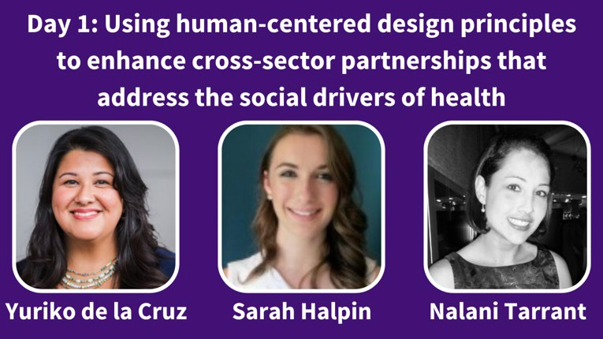
Speakers: Yuriko de la Cruz (National Association of Community Health Centers (NACHC)), Sarah Halpin (NACHC), Nalani Tarrant (NACHC)

Description:
Using human-centered design principles to identify opportunities for improved integration and advancing health equity is a relatively new approach. This framework is typically used in corporate settings; however, it can be equally powerful when utilized by community health centers, public health, and social service providers. The framework uses short, intensive bursts of facilitated sessions that allow teams to storyboard or personify the target population and anchor their efforts around the storyboard or persona. Additionally, the framework is an iterative process that allows participants to get closer to the needs of their community and identify strategies that may be more precise in addressing the root cause of barriers to comprehensive, integrated care. Finally, the design sprint framework honors the inherent solutions, experience, and skills of the cohort participants and builds upon the unearthed ideas and gifts of the community when intentionally including them.

As communities seek strategies that address and prevent the adverse health impacts of the social drivers of health (SDOH), they recognize that structural racism and discriminatory policies drive the SDOH and impede health equity. Effective cross-sector collaborations can be a force for driving equitable and sustainable upstream change to improve the health of structurally marginalized communities. During the education session, learnings from the use of human-centered design principles for cross-sector collaboration between community health centers, public health, and social service providers will be shared.

With support from the Robert Wood Johnson Foundation, the National Association of Community Health Centers (NACHC) and Association for Asian Pacific Community Health Organizations (AAPCHO) facilitated four design sprint cohorts in 2021. The design sprints used human-centered design principles that focused on strengthening community partnerships by using data-driven strategies to collaborate on upstream efforts to improve and sustain health equity, particularly for structurally

marginalized communities. Through this approach, participating cohort teams developed initiatives to tackle SDOH-related needs rooted in structural racism and inequities while strengthening cross-sector partnerships.

Learning Objectives:
- Participants will be able to describe how human-centered design principles can be applied specifically to problems of racial inequities in social care and upstream efforts that improve the health of structurally marginalized communities.
- Participants will be able to understand the importance of integrating community voice including racial and ethnic groups in health equity initiatives to improve systems of care.
- Participants will have the opportunity to practice a human-centered design skill, so that they can learn experientially.

Concurrent Sessions 11:10 AM -12 PM Pacific

Advancing racial equity in social care research and implementation: Lessons learned from research and community leaders
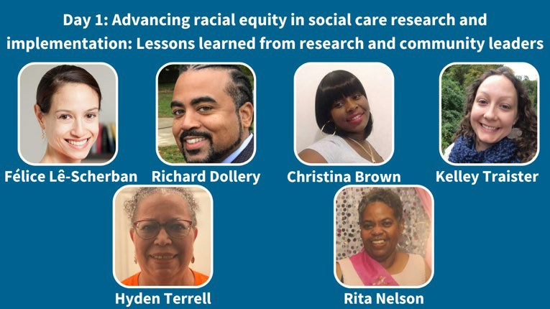
Speakers: Félice Lê-Scherban, Richard Dollery, Christina Brown, Kelley Traister, Hyden Terrell, Rita Nelson. All speakers are affiliated with Drexel University Dornsife School of Public Health and Drexel Urban Health Collaborative.

Description:
Our proposed session comprises three complementary presentations followed by a facilitated small-group discussion. The first presentation will be of results of a quantitative analysis of associations between maternal lifetime experiences of racial discrimination (EOD) and current household material hardships (difficulties affording food, housing, utilities, and health care) among families with young children. Analyses use survey data collected by Children’s HealthWatch (ChCHW), a network of pediatricians and public health researchers that has been conducting research since 1998 to inform policy decisions to alleviate hardships and improve equity for families with young children. ChCHW surveys caregivers of young children aged younger than 4 presenting at emergency departments or primary care clinics in safety-net hospital settings in 4 US cities (Boston, Little Rock, Minneapolis, Philadelphia). The data uses validated scales and published screening questions for EOD and household hardships (housing instability, energy insecurity, and healthcare hardships) as well as a combined measure of being hardship-free, defined as reporting none of the household hardships.
Covariate-adjusted logistic regression evaluated associations of maternal EOD frequency and each individual hardship as well as hardship-free status. Frequency of maternal lifetime EOD was associated with lower odds of being hardship-free in a dose-response manner. Healthcare provider education on trauma is important in order to be cognizant of and sensitive about the interplay of lived experience and basic needs access for providing trauma-informed patient care and social needs interventions.

The other two presentations will feature members of the Data & Research Core of the West Philly Promise Neighborhood (WPPN), a US Department of Education-funded place-based initiative to support 'cradle-to-career' opportunities for children living or going to school in a defined 2-square-mile area of West Philadelphia. Drexel University serves as the lead agency with over twenty

community, governmental, and service-provision partner organizations. WPPN aims to improve education, health and economic successes for children, their families, and communities. The WPPN Data & Research Core leads research and evaluation activities to support the delivery and measure the impacts of WPPN. The first presentation will describe WPPN’s community-engaged research activities, including a longitudinal population-based survey of caregivers administered by research-trained community resident surveyors. The presentation will also describe integration of this research with development of a place-based community health worker model to connect families to multiple systems of support. Originally funded 2017-2021, WPPN is currently in a no-cost-extension period during which Data & Research Core activities focus on data communication, dissemination, and capacity-building. Much of this work is led by WPPN Data Leads, who are former WPPN community surveyors who have transitioned into new positions spearheading community data communication, dissemination, and capacity-building activities. In the second WPPN presentation, Data Leads will share their experiences in community-engaged data collection and research in a community that has experienced substantial racial trauma and economic disinvestment.

Participants will then be divided into small groups in break-out rooms, each facilitated by a Data Lead, to discuss approaches to addressing racism and advancing racial equity in a hypothetical case study of a social care research project to be conducted in a health care setting. We will then re-convene the full group for a brief sharing-out session. These data and examples will provide attendees with deeper understanding of the ways racism and discrimination must be deliberately addressed in social care research and programs, and approaches to foster equal research partnerships with community members.

Learning Objectives:
- Describe relationships between interpersonal and structural racism and family access to basic needs and implications for clinical care and social care programs
- Define key elements of community-engaged research partnerships and how they advance racial health equity
- Apply concepts from presented research and community partnerships to designing social care research and programs in health care settings.

An institutional, community-connected approach to population health equity
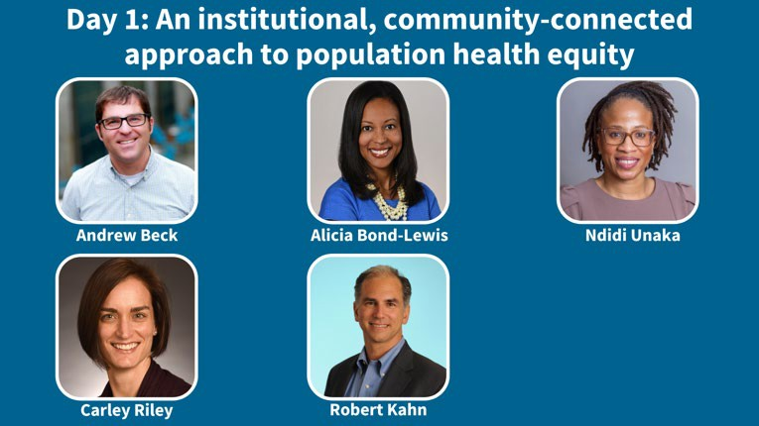

Speakers: Andrew Beck (University of Cincinnati College of Medicine; Divisions of General and Community Pediatrics and Hospital Medicine, Cincinnati Children’s Hospital Medical Center), Alicia Bond-Lewis (Dinsmore & Shohl LLP; Cincinnati Children’s Hospital Medical Center), Robert Kahn (Cincinnati Children's Hospital Medical Center), Ndidi Unaka (Cincinnati Children's Hospital Medical Center), Carley Riley (Cincinnati Children's Hospital Medical Center)

Description:
In this session, leaders from Cincinnati Children’s community and population health team will highlight an institutional approach to health equity. During the session, they will provide a history of their efforts, including an evolution from a condition-driven approach to the current community-connected, co-produced effort of today. They will highlight current initiatives that include a Health Equity Network that aims to eliminate racial inequities in health outcomes; neighborhood-based efforts to pursue food equity and the elimination of child abuse and neglect; and a city-wide activities aimed at building capabilities for transformation.

Differential impacts of social care interventions - Part 1
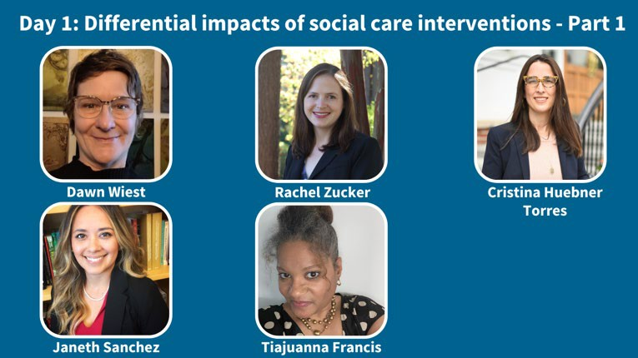
Speakers: Dawn Wiest (Camden Coalition), Rachel Zucker (KPCO - Institute for Health Research), Cristina Huebner Torres (Caring Health Center)
Moderator: Janeth Sanchez (National Cancer Institute (NCI) Office of Cancer Survivorship)
Discussant: Tiajuanna (Tia) Thames Francis (Patient Insight Institute; SIREN)

Description:
This is the first of two panel sessions presenting studies that examine heterogeneous treatment effects of social care among different racial or ethnic groups. Moderated by Janeth Sanchez, with reflections by discussant Tia Francis.

“Demographic differences in reach of an initiative in the healthcare setting to screen and refer patients for social needs” - Rachel Zucker (KPCO - Institute for Health Research)
Kaiser Permanente (KP) invested in a referral platform that allows KP providers to refer patients with social needs to community-based organizations. This presentation describes the reach of the initiative after 2 years of implementation and identifies characteristics of individuals who consent to receive services but do not successfully move through the system to receive services for one or more social needs.

“Community perspectives on social needs navigation outcomes in southern New Jersey” - Dawn Wiest (Camden Coalition)
We will describe a collaboration between a community-based organization, academic researchers, and community residents in building a project that incorporates health, social needs, economic, and demographic data to examine social needs navigation outcomes across three counties in southern New Jersey. We will discuss the results of our analysis and the role of community residents in making sense of the data and developing policy recommendations.

- “Cross-sectional assessment of racial, ethnic, and language equity in social risk screening and results in community health center patients” - Cristina Huebner Torres (Caring Health Center) We will describe rates of social risk screening— measured using financial resource strain data documented in the electronic health record (EHR)—by race, ethnicity and language, among adult community health center patients. We will report patterns in screening and reported risks; and use those to reflect on the implications of these patterns for achieving social care equity, including factors explaining these results and opportunities for addressing equity in screening implementation.

Experts by experience: uplifting and integrating the knowledge of people with lived experience of homelessness in social care research, education, and practice
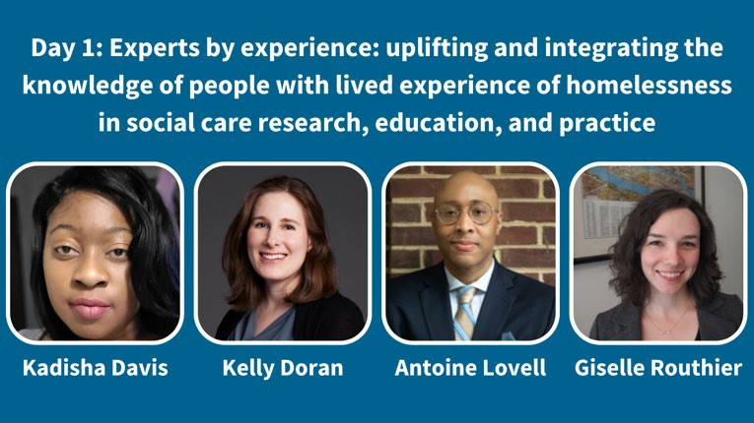
Speakers: Kadisha Davis (Health x Housing Lab, Department of Population Health, NYU Grossman School of Medicine), Kelly Doran (Ronald O. Perelman Department of Emergency Medicine and Department of Population Health, NYU Grossman School of Medicine), Antoine Lovell (School of Social Policy and Practice, Fordham University), Giselle Routhier (Health x Housing Lab, Department of Population Health, NYU Grossman School of Medicine)

Description:
Our session will take the format of a moderated discussion, comprised of two social care researchers/practitioners and two people with lived experience of homelessness, all of whom are part of the Health x Housing Lab at NYU Grossman School of Medicine. We will discuss specific examples of how the Lab has engaged people with lived experience of homelessness in social care research and education. Kadisha Davis will discuss her role as an educator in our 'Flipping the Script' teach-ins

where people with lived experience of homelessness and housing insecurity teach healthcare students, trainees, and practitioners about how health and housing are interconnected and offer solutions for better care integration and policy responses. Kadisha will also talk about her work as a summer consultant with the Lab, providing expertise on research projects and mentoring student interns. A Health x Housing Lab Advisory Committee member with lived experience of homelessness will discuss the role of the Lab's Advisory Committee, including developing the Lab's core values statements and shaping research proposals and educational events. Kelly Doran will provide an overview of the origins of the Health x Housing Lab and the need for social care research that bridges health and housing policy. All of the panelists will provide input on the effectiveness of our engagement strategies and opportunities for future work. Giselle Routhier will moderate the discussion.

To engage the audience, we will pose questions in between our moderated discussion topics about their opinions on and examples of engaging experts with lived experience. Specific questions for the audience will focus on gaining feedback on identified strategies, how to best engage people with lived experience and overcome barriers to engagement, how to prevent exploiting people with lived experience for internal aims, and what existing models other researchers are using. We will structure the presentation to be interactive and bidirectional so presenters and participants can share information, pose questions, and discuss identified topics.

Mindfulness

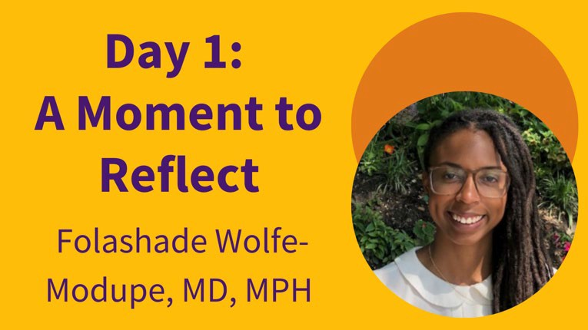
End the day with guided mindfulness and reflection exercises to ground ourselves and digest the day's learnings. Led by family physician and integrative practitioner Folashade "Flo" Wolfe-Modupe (University of California, San Francisco).

Day 2

Community Time
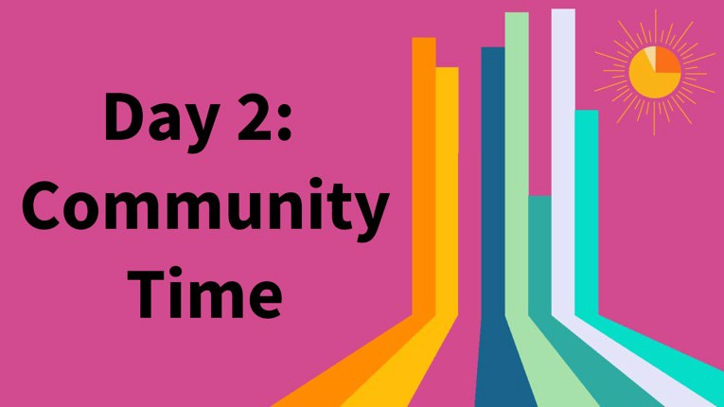
Community Time is an opportunity to connect with fellow meeting attendees before the day’s plenary. Join to meet other equity-minded social care stakeholders in small groups and reflect on challenges you’re facing in your racial health equity efforts.

Plenary

Measuring racial health equity in social care research
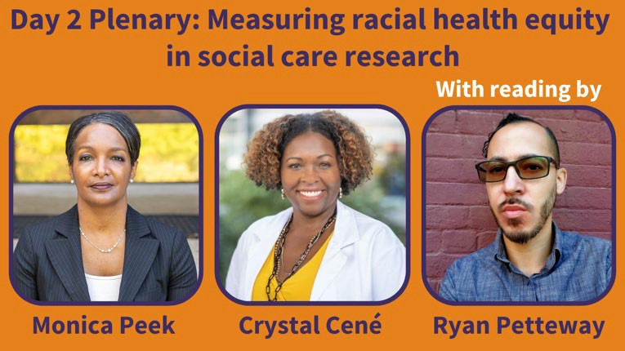
Speakers: Crystal Cené (UC San Diego Health), Monica Peek (University of Chicago Medicine), Ryan Petteway (Oregon Health & Science University–Portland State University School of Public Health)

Description:
Panel with Drs. Cené and Peek

Each year an increasing number of original research articles are published about healthcare-
based social care programs and policies. However, relatively few of these studies measure the impact of social care interventions on different racial or ethnic minority groups. More information
about differential impacts could help to improve the implementation – and ideally the impacts – of social care. Physician scientists Crystal Cené and Monica Peek will briefly share findings from a recent review they co-led, funded by the Patient Centered Outcomes Research Institute
(PCORI), which involved a collaboration with researchers from both RTI and SIREN. Join Drs. Peek and Cené in this fireside chat as they explore what counts as measuring racial health equity (including how they developed a novel framework on “thoughtfulness” and “informativeness”), how much (or little) racial health equity has been explicitly described or measured in the social care interventions evidence base to date, and concrete next steps for researchers and practitioners that can strengthen the racial health equity implications of their work. Participants will be able to ask questions of the speakers using the Q&A function.

Two Poems for Poetic Health Justice: Poetry as Praxis for an Antiracist and Decolonized Future of ‘Radical Possibility’ with Ryan Petteway
Health research remains ensconced in a heavily positivist, reductionist, settler-colonial, racial-capitalist “ritual” of knowledge extractivism and expropriation wherein credentialed researchers mine marginalized communities for data to (re)package and (re)distribute as their (our) own knowledge.
Much of this work has focused on racial health inequities while, curiously, leaving unexamined matters of positionality, epistemic equity, and procedural justice in the production and curation of knowledges/narratives about racialized subjects (here, perhaps better described as “objects”). In the US, this production is dominated and curated mostly by White scholars—from tenure-track faculty positions, to funding review panels, to editorial boards, to peer-review bodies. In short, the public/medical health knowledge production and curation enterprise is structurally racist, and it is time that we confront the inherent contradictions of a health equity discourse that fails to interrogate the racialized power dynamics that animate it. Moreover, it is time that we remix the canon and forge a future health research capable of doing our health narratives epistemic—and poetic—justice. In this spirit, I draw from social epidemiology, critical, critical race, Black feminist, and decolonizing theory literatures to engage poetry as a site of “radical openness and possibility” (hooks)—an inclusive space of resistance for the production of counternarratives within discourse of health (in)equity. “Something, Something, Something by Race, 2021” and “RELATIVES//Risks” enact public health critical race praxis (Ford & Airhihenbuwa) principles of “voice” and “disciplinary self-critique” as mode of resistance to counter the epistemic violence of our structurally racist and racial-capitalist health inequities research enterprise. In each poem, I foreground considerations of epistemic justice/oppression, data (in)justice, and narrative power—illustrating poetry as praxis to challenge public health’s history of violence against our bodies, its (re)colonization of our lives, and its (a)political silence on matters of epistemic and social injustice. These works suggest the epistemological, ethical, and material imperative of remixing/reimagining health knowledge production, expression, and curation practices to more fully—and unapologetically—"center the margins,” with poetry a necessary format of health equity discourse for resistance and healing.

10:10-11:00 AM Pacific (1:10–2:00 PM Eastern)

Concurrent Sessions 10:10-11am Pacific

Measuring racial health equity in social care research
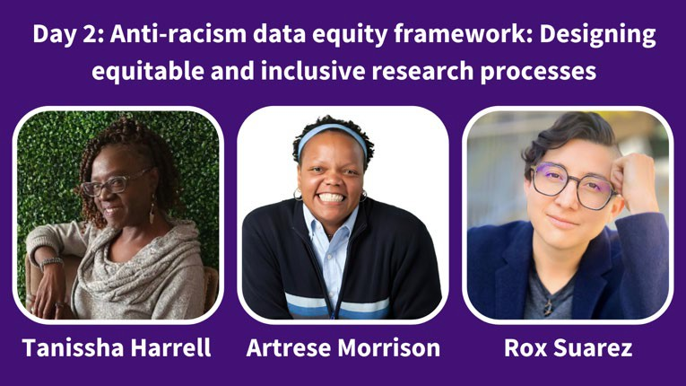
Speakers: Tanissha Harrell (211/CIE San Diego), Artrese Morrison (Health Leads), Rox Suarez (211/CIE San Diego)

Description:
This interactive session will be co-facilitated by three speakers who will offer an energetic and collaborative conversation to share an overview of the data equity framework. Each speaker will introduce themselves using "I AM" affirmations and invite participants to do the same in the chat. The interactive format will allow for questions from participants and create a shared learning experience. The session will begin with framing the conversation and an invitation to participants in a grounding exercise to set intentions and aspiration for our time together.

Using human- centered design methods and tools such as Miro to capture our collective discussion and include opportunity for collective communication our speakers will facilitate and guide participants through an engaging process that helps participants to reflect on personal biases as participants engage in this work. Each participant that attends if they desire will get a copy of the Miro board(s) created from this experience to continue the conversation and share.

Learning Objectives
- Present the landscape of data system design types, including those that center anti-racist practices.
- Discuss the challenges of developing, establishing, and maintaining anti-racist data design practices.
- Review and discuss strategic visioning to reflect on individual and institutional practices that do harm and transform them into anti-racists solution.
- Reflect on your personal biases as you engage in this work.

10:10-11:00 AM Pacific (1:10–2:00 PM Eastern)

Designing more equitable social care
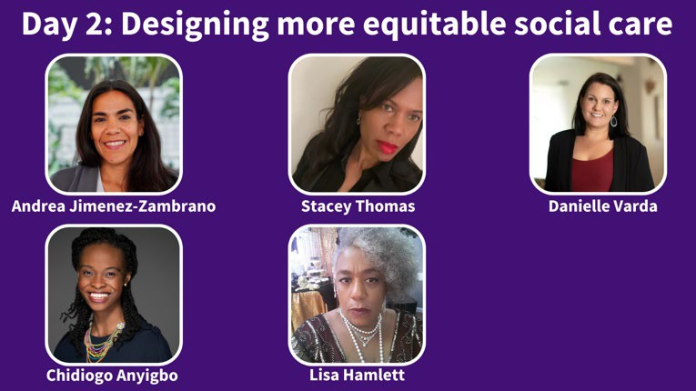
Speakers: Stacey Thomas (Health Leads), Andrea Jimenez-Zambrano (University of Colorado), Danielle Varda and Kyra Stoute (Visible Network Labs)
Moderator: Chidiogo Anyigbo (Cincinnati Children’s Hospital Medical Center)
Discussant: Lisa Hamlett (Patient Insight Institute; SIREN)

Description:
Presentations in this session highlight how careful attention to the ways in which social care is implemented and who is at the decision-making table can lead to more equitable interventions.

- “Informed consent can be a driver of inequity” Stacey Thomas (Health Leads)
The presentation explores how informed consent methods, in the context of modern data exchanges may perpetuate inequities by limiting or eliminating choice for marginalized populations. Further, it offers potential solutions and considerations as proposed by impacted community members and patients.

- “Tailoring social needs and social support screeners for young adults” Danielle Varda and Kyra Stoute (Visible Network Labs)
As part of a study on youth social connectedness as a factor determining outcomes for adolescent youth, four Fellows (ages 19-21) from underserved communities conducted research in partnership with the VNL data science team, to tailor PARTNERme, a social need and social connectedness screener. Their lived experiences and their interviews with other youth informed how the screener was tailored for young adults and it was administered to 40+ young adults to understand how youth conceptualized the role of social connectedness influences in their lives.

“Engaging members of systematically disadvantaged communities to identify priority outcomes of success for a school-based asthma management program” Andrea Jimenez-Zambrano (University of Colorado)
Asthma is a common chronic disease for children that disproportionately impacts low-income families. As part of scaling our school-based asthma self-management program to 5 new disadvantaged regions of Colorado, we successfully engaged Community Advisory Boards (CABs) in each of these 5 regions to identify what they would consider as priority outcomes of success for the program in terms of impact on social determinants of health (SDOH) and other factors.

10:10-11:00 AM Pacific (1:10–2:00 PM Eastern)

Socioeconomic mobility and health equity: Lessons from the field
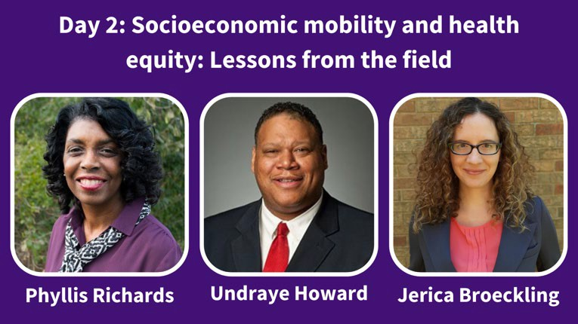
Speakers: Phyllis Richards (Social Current), Undraye Howard (Social Current), Jerica Broeckling (Social Current)

Description:
In July 2020, the Alliance (now known as Social Current) hosted a series of virtual Community Conversations with community leaders across the country, creating space for people to share strategies, successes, and challenges in their work to address the root causes of poverty. Several common themes emerged over the series of discussions with nearly 100 individuals representing community organizations, schools, public agencies, and health care. The conversations made clear that sustainable solutions will require significant shifts in how we think about and implement socioeconomic mobility efforts.

This presentation will focus on the six major themes surfaced from our 2020 National Community Conversations, highlighting both the entrenched, systemic challenges that human-serving organizations face in their anti-poverty work while centering on racial equity as well as core strategies and promising practices. The discussion will include stories of how organizations are focusing on health equity and socioeconomic wellbeing.

Learning Objectives
- Learn how social care practitioners are working to address common barriers that nonprofits face when addressing socioeconomic wellbeing and health equity.
- Discuss their own challenges successes and promising practices.

10:10-11:00 AM Pacific (1:10–2:00 PM Eastern)

Uncovering and addressing disparities in health-related social needs, social needs screening and navigation: Using data to drive change
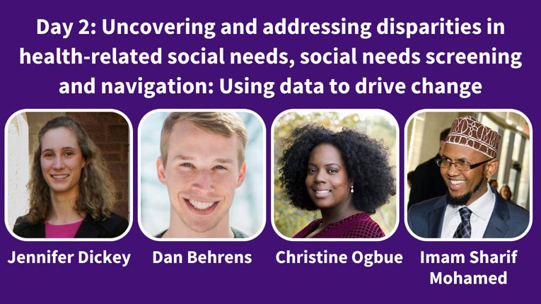
Speakers: Jennifer Dickey (Mathematica), Dan Behrens (Allina Health), Christine Ogbue (CMS/CMMI), Imam Sharif Mohamed (Open Path Resources)

Description:
The Accountable Health Communities Model (AHC) from the Centers for Medicare and Medicaid Services (CMS) tests whether addressing Medicare and Medicaid beneficiaries’ health-related social needs (HRSNs) through screening, referral, and navigation services will reduce health care costs and use. The model addresses the gap between clinical care and community services and, over five years, has helped its participants test service delivery approaches meant to link beneficiaries with community services that address their HRSNs (that is, needs related to housing, food, utilities, interpersonal violence, and transportation). The session shares model-wide racial and ethnic evaluation findings regarding screening and navigation and ways to address them, highlights how one participant and its partners tried to reduce bias and discrimination in social needs screening, and explains how lessons from that experience inform the organization’s efforts to engage community partners to drive health equity.

Presenter 1: The AHC lead project officer will summarize the AHC Model design and describe the mixed methods analysis employed to assess characteristics associated with HRSN screening, navigation eligibility, and racial ethnic minorities. Early analysis shows that racial and ethnic minorities are overrepresented in the navigation-eligible population. She will share qualitative findings that explain possible reasons for disparities in screening and needs resolution.

Presenter 2: A staff member from Allina Health System will share how its data revealed that despite Black, Somali, and Latinx patients having twice the need for HRSN services, they were offered HRSN screening at 10% lower rates than White, non-Hispanic patients who spoke English as their first language. Their team used these data as a launching point to engage with an equity team for process improvement, including conducting focus groups and interviewing clinic staff to understand barriers to HRSN screening and designing training to address these barriers. The team took lessons from the AHC Model to inform its system-wide efforts to effectively engage community partners and members to drive health equity. He will also describe the coalition of providers, payers, Minnesota Medicaid,

10:10-11:00 AM Pacific (1:10–2:00 PM Eastern)

and community members are developing a community-wide approach to connect resources and use referral technology platforms.

Presenter 3: A staff member from Open Path Resources (OPR), a community-based organization serving local East African immigrant families and community members, will describe OPR’s partnership with Allina to address disparities in colorectal cancer screening. Together, they created a multipronged intervention: OPR developed and provided cultural awareness training for health care providers and is developing tools to help frontline staff provide culturally responsive care. Allina employs a community health worker to bridge access and communication gaps between community members and providers and help patients with HRSNs. The staff member will describe OPR’s experience partnering with a large health system and considerations for similar partnerships.

Facilitation: We propose using MURAL, a digital workspace collaboration tool. After each presentation, participants will share what resonated with them and what questions it raised. After the three presenters finish, we will reflect on those comments and use human-centered design principles and MURAL to engage participants and unearth lessons for patients, community and health service providers, health systems and state and federal policymakers.

Learning Objectives:
- Understand how race as a social and cultural construct affects assessment and redress of social needs.
- Apply mixed-methods data with community engagement to inform program implementation and policymaking.
- Consider how you can apply the lessons learned from the Accountable Health Communities Model in your setting.

Concurrent Sessions 11:10am-12pm Pacific

Anti-racist social care research methods in action
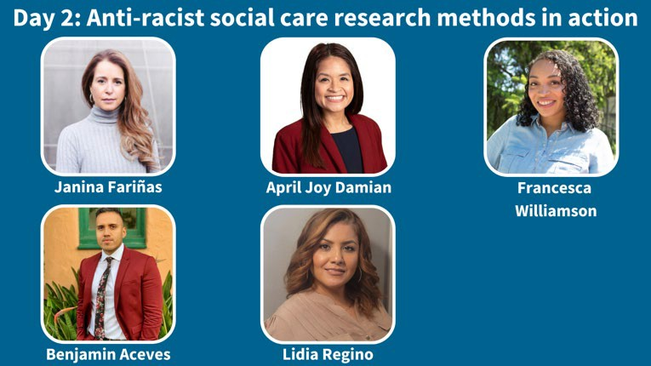
Speakers: Janina Fariñas (La Cocina & L’Ancla), April Joy Damian (Weitzman Institute), Francesca Williamson (Indiana University School of Medicine)
Moderator: Benjamin Aceves (San Diego State University)
Discussant: Lidia Regino (University of New Mexico)

Description:
Presentations showcase research projects that promote the engagement of impacted communities and dismantle traditional power dynamics; discussion will explore ways to apply these methods in social care research. Moderated by Benjamín Aceves, with reflections by discussant Lidia Regino.

“Campeones de la salud: codesign and systems change supporting critical health literacy” -
Janina Fariñas (La Cocina & L'Ancla)
To create desirable outcomes we recognize them as emergent properties of people’s lives as systems containing their networks of care. We seek to change outcomes by changing systems to produce different patterns than those we currently see. To produce these patterns we need to make our systems healthier, enabling people to collaborate and learn together.

- “Examining the health and social needs of youth of color and LGBTQ+ youth during COVID through Photovoice” - April Joy Damian (Weitzman Institute)
This presentation features a youth-driven project that applies photovoice, a community-based participatory research method, where youth of color and LGBTQ+ youth use photography to visually capture the health and health related social needs they are facing, particularly during the COVID-19 pandemic. Secondarily, the presentation features lessons learned from youth-serving community based organizations on the barriers and opportunities to addressing the health and social needs of youth of color and LGBTQ+ youth during COVID.

“The role of reflective interventionist conversation analysis in advancing racial health equity”
- Francesca Williamson (Indiana University School of Medicine)

This presentation provides an overview of reflective interventionist conversation analysis, a participatory approach to designing and conducting research on social interactions to inform practice. Using an illustrative study of audio-recorded visits with families of color in pediatric oncology settings, we explore the affordances and constraints of using this approach to design and implement interaction-focused and educational interventions for racial health equity.

Creating sustainable infrastructure to support cancer survivors by identifying and addressing social risk factors and reducing health inequities
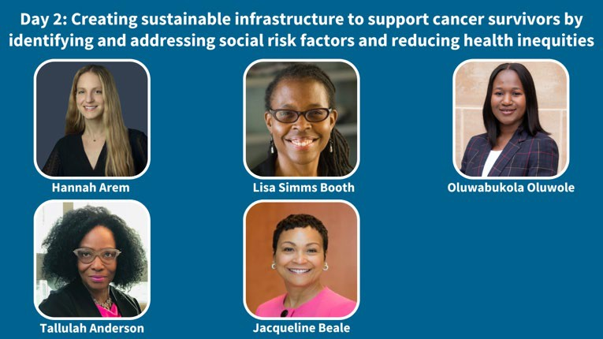
Speakers: Hannah Arem (MedStar Health Research Institute), Lisa Simms Booth (Smith Center for Healing and the Arts), Oluwabukola Oluwole (MedStar Health Research Institute), Tallulah Anderson (2for2 Boobs), Jacqueline Beale (MedStar Health Research Institute)

Description:
Through this session we will include multilevel perspectives on the potential for social risk factor screening and referral processes to support racial equity. Participants will be encouraged to consider how implicit bias and racism impacts patient experiences in both hospital and community settings.

Cancer survivors experience long-term challenges after completion of cancer treatment including financial toxicity, social isolation, and difficulties establishing a new normal. There is little published research on how to integrate social risk factor screening and referral processes to assess and address these needs into cancer survivorship care, and in particular to achieve racial equity. To this end it is critical to incorporate diverse perspectives on social risk factor screening in intervention planning including from the patient, those conducting screening and referral services, and those providing services to the members of the community.

We conducted a series of interviews with patients, providers, and community-based organizations in Washington, DC to understand how to create meaningful exchanges between three Washington DC healthcare systems and community-based organizations to achieve racial equity. These interviews informed our initial roll out of social risk factor screening and referral processes to appropriately serve historically marginalized populations. The overall study objective is to deliver social risk factor screening to all breast and prostate cancer patients across three cancer centers in Washington DC and to provide community health worker support to address social, practical, and emotional needs.
Simultaneously, we will conduct anti-bias training at the 3 cancer institutes and will measure patient experiences of discrimination in medical settings.

There is a need to consider the cascade of screening, referring, and providing for cancer survivor needs with a focus on incorporating the patient perspective and destigmatizing social needs. In interviews we found that patients largely supported being asked about social risk factors in the healthcare setting. From the provider perspective limitations included appropriate referral channels for identified needs, sufficient staffing to support patients, and competing priorities. Community-based organizations cited a need for better coordinated care, awareness of power dynamics between large healthcare systems and community-based organizations, and engaging patients early in the treatment experience to provide needed support services. Ongoing lessons learned and adaptations to screening and referral protocols will be presented.

Our speakers will present on experiences with experiencing interactions in the clinical and community settings and will lay out lessons learned from decades of experience working in the community and bridging healthcare settings to reflect on better coordinating efforts to serve cancer survivors and reduce health inequities.

Equity assessment tools and measures
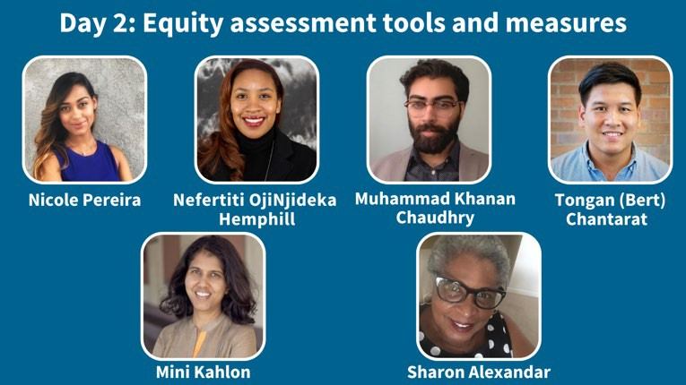

Speakers: Nicole Pereira (Blue Shield of CA), Nefertiti OjiNjideka Hemphill (ATW Health Solutions), Muhammad Khanan Chaudhry (ATW Health Solutions), Tongan “Bert” Chantarat (University of Minnesota)
Moderator: Mini Kahlon (Dell Medical School)
Discussant: Sharon Alexander (Patient Insight Institute; SIREN)

Description:
- “Turning up the HEAT on health equity: developing a tool to systematically assess the health equity impact of health transformation initiatives” Nicole Pereira (Blue Shield of CA)
Many organizations want to achieve racial health equity in their communities but lack tools for measuring their progress toward their goals. Blue Shield CA (BSC) developed the Health Equity Assessment Tool (HEAT) to help researchers and evaluators measure their progress toward achieving their health equity goals.

“The importance of policy assessment to dismantle the impact of racism on the availability and effectiveness of social care” Nefertiti OjiNjideka Hemphill and Muhammad Khanan Chaudhry (ATW Health Solutions)

Many young people in the U.S. experience poor mental health, especially youth who identify as Black, Asian American, Native Hawaiians or Pacific Islanders, and Muslim. This presentation will discuss how public policy affects mental health for these groups by shaping the social conditions where they live, go to school, work, play and pray.
- "Measuring structural racism" Tongtan “Bert” Chantarat (University of Minnesota)
This presentation will discuss the recent development in structural racism measurement in health research and future steps to improve the science around antiracist research.

Modern day elderhood councils: A community-based intervention
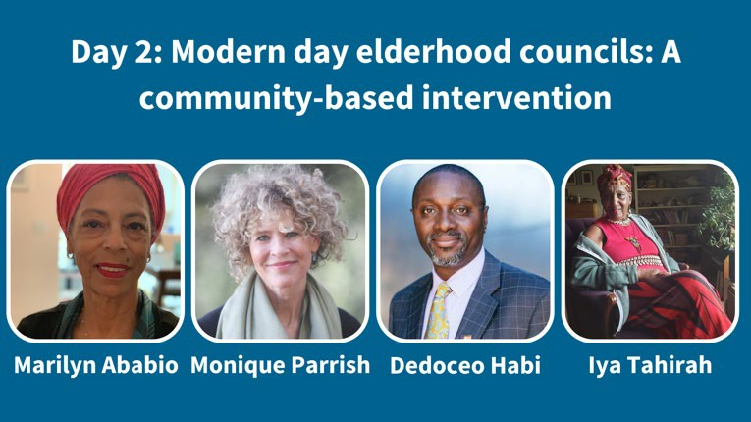
Speakers: Marilyn Ababio (Comfort Homesake), Monique Parrish (LifeCourse Strategies), Dedoceo Habi (Author, community health advocate, and veteran), Iya Tahirah (Guiding elder)

Description:
Our proposal is to unearth the role of elders in the African American community as a modern construct. We intend to collect culturally relevant data and evaluate the organizational structure of existing elder council models in five US Cities. The goal is to identify a modern day construct for elder councils as a focal point for bridging the gap between outpatient follow-up/case management services and community based health and social needs. We offer a series of presenters each with a chapter in Comfort Homesake’s story of building a community based presence to implement whole person care as a building block of community empowerment.
Our presentation will begin with ritual led by our guiding elder, Iya Tahirah who will elaborate on our working definition of elderhood: "Means to have lived life in a way that brings forth a guidepost or navigation for those who come behind us. That means not passing on pain and suffering but recalibrating experiences in such a way that others can transmute and heal."
Dr. Monique Parrish will describe how health systems attempt to overcome health equity issues. She will highlight the concept of whole person care in view of health systems’ efforts and the barriers to delivering much needed community resources to aide patients and their caregivers. She will also discuss the potential for community-based organizations to embrace whole person care as a remedy for their health and social needs.
Third presenter, Mr. Dedoceo Habi will discuss modern day conceptual elements of elder councils and their evolution over time from the council’s traditional indigenous role to its current function. Mr.

Habi will identify a plethora of research avenues as we reimagine communities where growth and development is guided by connection to and wisdom of our elders; communities where we don’t discard knowledge and lives lived but instead embrace what has come before as a path towards better lives to come.
Marilyn Ababio will discuss the elements of the innovation between the health care services agency and the social services agency to demonstrate the nexus that institutionalized the Alameda County Care Partners program. She then will describe Comfort Homesake’s investment of over 15 years building capacity to deliver culturally relevant service to seniors; low income populations; the formerly incarcerated; people with mental health diagnosis, and other citizens who are managing a chronic disease, with a serious illness, or facing end-of-life. Her final focus is a request for funding a research pilot featuring one elder council to identify how health care systems can work together with community based organizations to bring together health resources that address the social determinates of health. There are gaps in health care services delivery systems that relate to the value proposition for people of color. The overarching question we wish to study is how would a health council that embodies community beliefs, thoughts and intentions affect trust in the health system of care. The research opportunities open to discovery are:
- How do elder councils identify elders to serve and what education/training is needed to support health care decision making?
- What is the elder council’s hearing and deliberation methodology? How do we measure community acceptance of elder council decisions? • How can we measure the value to the community of an elder council’s existence?
- How do elder councils bring resources and power into the community?
- What considerations will elder council decisionmakers evaluate with regard to interacting with health systems and providers interested in gaining access to community members? For example: COVID pandemic and emergency preparedness.

Learning Objectives
- Participant will understand the difference between aged and elderhood
- Participant will describe the principles that guide whole person care
- Participant will understand the historical significance of elder councils in the African American community
- Participants will describe the elements of capacity building

Mindfulness
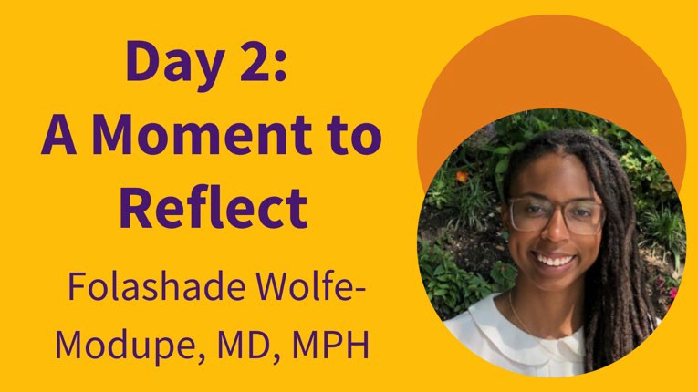
End the day with guided mindfulness and reflection exercises to ground ourselves and digest the day's learnings. Led by family physician and integrative practitioner Folashade "Flo" Wolfe-Modupe.

Day 3

Interactive Small Groups

“Un-plenary” Reflection and Action Planning
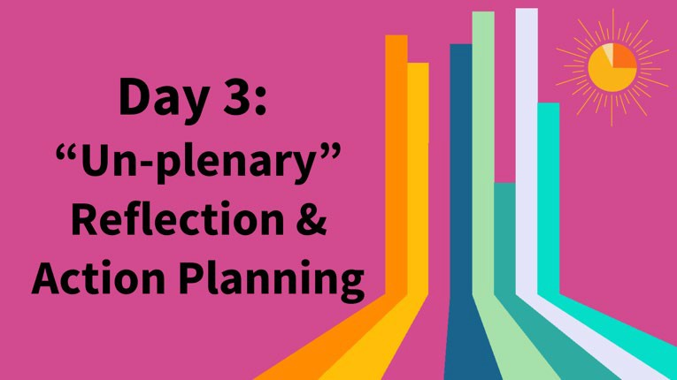
In this “Un-plenary” Reflection & Action Planning session, participants will have the opportunity to interact in small groups in breakout rooms to discuss learnings from the conference and what the field needs to do differently to better advance racial equity. It is time to get to the brass tacks of how we can apply the conference’s learnings to our work, individually and collectively.
To make this session as useful to participants as possible, breakout rooms will be based on topics that many participants have had their biggest meeting takeaway about, as well as important topics that didn’t have dedicated sessions this year.

Concurrent Sessions 10:10-11am Pacific

Leveraging health care organizations’ economic resources to advance racial equity at the community-level
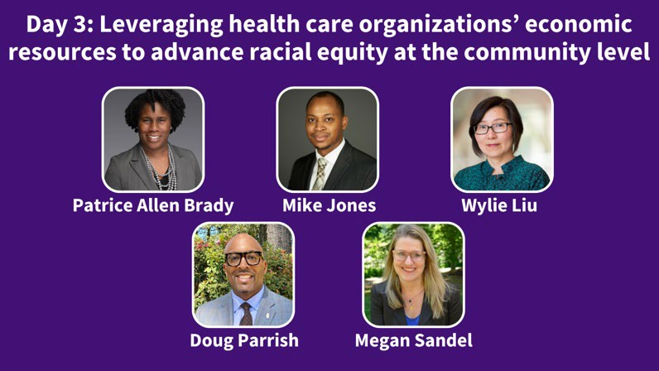
Speakers: Patrice Allen Brady (Healthy Homes – Community Development for All People and Nationwide Children’s Hospital), Mike Jones (University of California, San Francisco (UCSF)), Wylie Liu (UCSF), Doug Parrish (Red Dipper Inc.; UCSF), Megan Sandel (Boston University Medical School)

Description:
Health care organizations can advance racial health equity not only through their clinical work, but also by partnering with local organizations to leverage their institution’s economic resources
to improve the economic wellbeing of local under-resourced communities, thereby improving health outcomes. Popularized as the Anchor Institution Model by the Healthcare Anchor Network, this includes creating on-ramps and pathways to family sustaining jobs for historically underserved communities, shifting procurement of goods and services to small, local, diverse businesses, and providing grants and loans to support racial-equity-focused local community development. This session will feature two health care organizations’ lessons learned in this community-level anchor institution work. Patrice Allen Brady, Senior Engagement Manager with Healthy Homes, a Columbus, Ohio nonprofit affordable housing partnership between Community Development for All People and Nationwide Children’s Hospital, will describe how the Healthy Homes partnership developed and how it works to help revitalize housing in historically underinvested neighborhoods in Columbus. Wylie Liu, Director of the Center for Community Engagement, and Michael Jones, Workforce Development Organizational Consultant, both from the University of California, San Francisco (UCSF), will describe UCSF’s work to improve local economic security by hiring and promoting staff and procuring goods and services from local historically underserved communities, as well as providing capital for loans to support these same communities. Doug Parrish, President and CEO of Red Dipper, Inc., a small minority-owned electrical contractor in San Francisco and Co-Chair of the UCSF Anchor Institution Mission Procurement Sub-committee, will share his recommendations for how health care organizations can support small local diverse businesses. Megan Sandel, Associate Professor of Pediatrics at Boston University Medical School and a national leader in health and housing, will moderate this session.

Differential impacts of social care interventions – Part 2
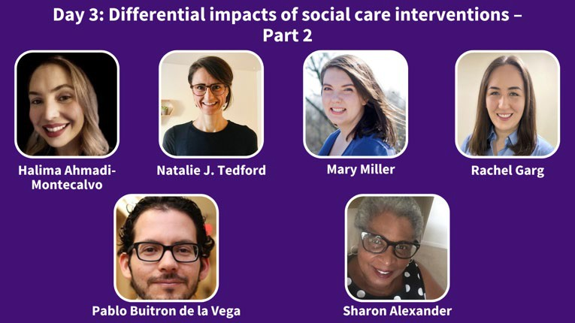
Speakers: Halima Ahmadi-Montecalvo (Unite Us), Natalie J. Tedford (University of Utah Health | Primary Children's Hospital), Mary Miller (United Way Worldwide), Rachel Garg (Washington University in St Louis)
Moderator: Pablo Buitrón de la Vega (Boston University School of Medicine; Boston Medical Center)
Discussant: Sharon Alexander (Patient Insight Institute; SIREN)

Description:
This is the second panel session presenting studies that examined heterogeneous treatment effects of social care among different racial or ethnic groups. This session is moderated by Pablo Buitrón de la Vega, with remarks by discussant Sharon Alexander.

“Social care in the time of COVID-19: insights from technology-powered coordinated care networks” Halima Ahmadi-Montecalvo (Unite Us)
Effectively addressing the social needs of our communities relies on leveraging dynamic sets of data to provide insight into diverse clients needs. This study leverages a large, unique dataset to describe the top social needs of clients served by the Unite Us time period during the COVID-19 pandemic and to compare these needs across racial/ethnic groups.

- “Social needs screening during pediatric emergency department visits: language differences in reported needs” Natalie Tedford (University of Utah Health | Primary Children's Hospital) Screening for social needs in an urban pediatric emergency department revealed significant levels of unmet social needs (USN) and disparities related to caregiver’s language, racial/ethnic identity of child, and insurance status of child. We found that differences also existed in how English- and Spanish-speaking caregivers responded to our social need inquiries.

- “Exploring social care research possibilities with 211” Mary Miller (United Way Worldwide) and
Rachel Garg (Washington University in St Louis)
By capturing every social need expressed by over 21 million annual contacts to 211 and visitors to 211 websites, 211 is effectively the nation’s leading surveillance system for social needs. This session highlights recent research and innovations using 211-related data and poses questions and opportunities for future research endeavors.

How do we put anti-racism into practice in tech-forward SDOH interventions, and what does it mean for the field?
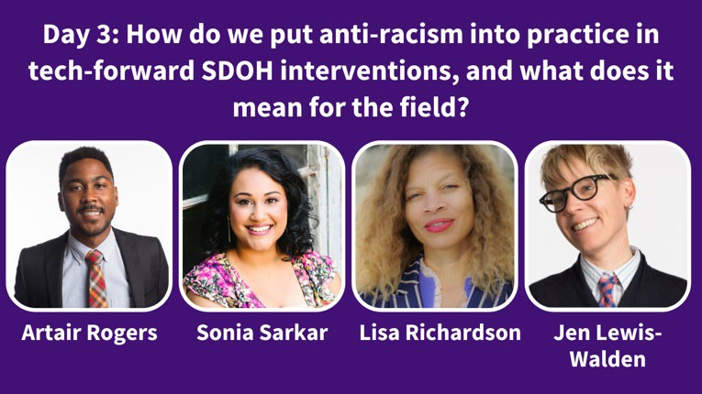
Speakers: Artair Rogers (Harvard FXB Center for Health and Human Rights), Sonia Sarkar (Shift Health Accelerator, Johns Hopkins University, Common Future), Lisa Richardson (Shift Health Accelerator, Institute for Women and Ethnic Studies), Jen Lewis-Walden (Shift Health Accelerator, Build Healthy Places Network)

Description:
Our session will offer space to deepen actionable research and expand collaboration to center community governance and ownership, and associated impacts, for future tech-forward SDOH investments. Additionally, as social care researchers, this session will focus on the role researchers can play in promoting anti-racism and equity in the SDOH sector, particularly regarding the operations and data management of SDOH interventions. Our team brings unique and diverse lived experience. Artair Rogers, MS, Harvard FXB Center for Health and Human Rights, is the principal author on the forthcoming paper entitled Profiting off of BIPOC Pain: The Capital Gain of SDOH Technology Solutions at the Expense of the BIPOC Community and brings deep experience in healthcare, analytics, and support of Community Information Exchange and SDOH intervention efforts to center more equitable approaches. Lisa Richardson, PhD, is a public health practitioner and expert in community-based participatory research and community building for racial equity. Sonia Sarkar, DrPH, brings expertise in innovations at the intersection of anchor institution strategies, healthcare investments and democratizing capital. Finally, Jen Lewis-Walden, MA, MEM, brings practitioner expertise leveraging multi-sector efforts, hospital community benefit and community led network-building. The session will build on our work in the field to articulate the harms in the tech-forward SDOH investment space and our national learning and action network advancing healthcare accountability for anti-racism and equity commitments. This session will highlight the critical role of researchers and evaluators to ensure that the expanding SDOH field, particularly social needs technology platforms and associated SDOH interventions, are held accountable to applying data ethics principles and helping to build the base of evidence and value case for community governance. Our session will yield actionable insights for future research and collaboration by challenging key assumptions in this growing field and invite researchers and evaluators to apply anti-racism commitments to their work, centering equitable data collection, interpretation, analysis, and evaluation as key components of the SDOH sector.

Learning Objectives
- Map opportunities for healthcare accountability through community governance and ownership of social needs and SDOH investments
- Co-create collaboration to deepen actionable insights and investments to center the knowledge and wisdom of communities advancing health and racial equity
- Build interactive dialogue with field researchers and evaluators around their unique and critical role to embed anti-racist practices within the SDOH technology space, particularly in regards to SDOH intervention implementation and data management.

Minding gaps in health care and social care
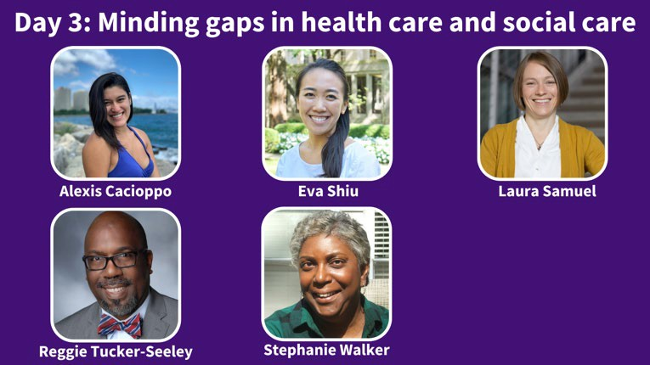
Speakers: Alexis Cacioppo (The University of Chicago Pritzker School of Medicine), Eva Shiu (University of Chicago), Laura Samuel (Johns Hopkins School of Nursing)
Moderator: Reggie Tucker-Seeley (ZERO-The End of Prostate Cancer)
Discussant: Stephanie Walker (Patient Insight Institute; SIREN)

Description:
The presentations on this panel explore how racism at multiple levels interacts with social needs trajectories. This session is moderated by Reggie Tucker-Seeley, with remarks by discussant Stephanie Walker.

- “Food insecurity and healthcare-based discrimination among predominantly African American/Black parents and caregivers of children hospitalized during the COVID-19 pandemic” – Alexis Cacioppo (The University of Chicago Pritzker School of Medicine)
This study examines how food insecurity relates to experiences of discrimination in the children’s hospital setting in a sample of predominantly African American/Black parents and caregivers of hospitalized children. We found that food insecurity was common and significantly related to more frequent experiences of discrimination during a child’s hospitalization.

“Nuanced interventions & policies are needed to address the widening gap in health-related socioeconomic risks experienced by East and Southeast Asian women during the COVID-19 pandemic” – Eva Shiu (University of Chicago)
This presentation is about the COVID-19 pandemic’s impact on racial and ethnic disparities in health-related socioeconomic risks, like food insecurity and transportation difficulties, among U.S. women. We found that nearly half of U.S. women reported new or worsening health-related

socioeconomic risks early in the pandemic, but East and Southeast women were disproportionately affected by these pandemic-related changes.

- “Food insecurity, race, and Supplemental Nutrition Assistance Program participation: The racial SNAP gap” – Laura Samuel (Johns Hopkins School of Nursing)
The Supplemental Nutrition Assistance Program (SNAP) can reduce food insecurity and people who are Black and Hispanic are more likely to participate in SNAP than those who are White. However, they don't participate as often as they should given their higher rates of food insecurity and have higher rates of food insecurity, even when they receive SNAP benefits.

Closing Plenary

Actions speak louder: Fulfilling social care’s racial health equity potential
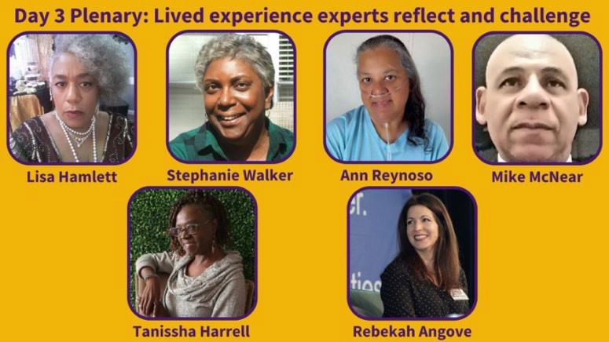
Speakers: Lisa Hamlett (Patient Insight Institute; SIREN), Stephanie Walker (Patient Insight Institute; SIREN), Ann Reynoso (Patient Insight Institute; SIREN), Mike McNear (Patient Insight Institute; SIREN), Tanissha Harrell (211/CIE San Diego), Rebekah Angove (Patient Insight Institute, Patient Advocate Foundation)

Description:
Join us around a virtual kitchen table for a final panel featuring four Experts by Experience as they reflect on their takeaways from the meeting, express what’s most important to them, and point out opportunities for more research or action. The goal of this session is for participants to leave the SIREN National Research Meeting feeling grounded in what matters to patients with lived experience of racism and socioeconomic challenges, fired up about working in ways that actively promote racial health equity, and focused on what comes next. This panel features Lisa Hamlett, Mike McNear, Ann Reynoso, and Stephanie Walker, and will be facilitated by Tanissha Harrell and Rebekah Angove.

