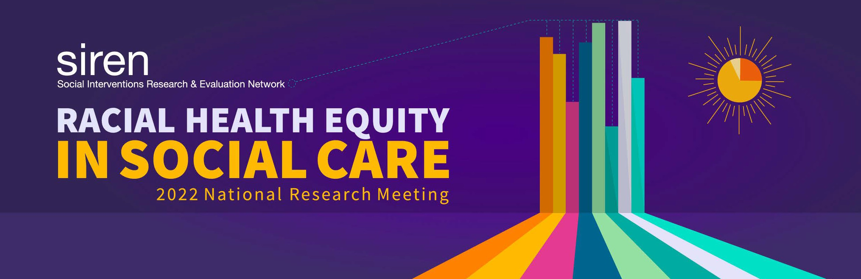

How can we better advance racial equity in social care research?

Learnings from small group discussions at the SIREN 2022 National Research Meeting
As part of the SIREN 2022 National Research Meeting on Racial Health Equity in Social Care, in October 2022, 144 attendees (including researchers, clinicians, and community members) gathered in small breakout groups for one hour to discuss conference learnings and consider what the field could do differently to advance racial health equity. Below we summarize the group discussions and highlight National Research Meeting content that helps to illustrate key points. While not comprehensive, we hope that this summary provides some actions that researchers, research institutions, and research funders can take to better advance racial health equity.

What practices do researchers need to change to better advance racial health equity?

Include lived experience and community partner expertise in research every step of the way, from conceptualization through to dissemination.
  - Engage thoughtfully and in ways that don’t cause harm.
  - Move at the speed of mutual trust towards deeper levels of collaboration.
  - Ensure an infrastructure to compensate (e.g., for time, childcare, transportation) and provide other supports (e.g., coaching, access to other opportunities) to lived experience experts and/or community partners.

Always disseminate study results to participants and/or community members.

Drexel University Urban Health Collaborative launched an intervention study in a disadvantaged neighborhood that had been heavily researched with little in return, leading to deep mistrust in the university’s intentions. To earn the community’s trust and ensure the research project addressed community concerns, the Collabo-rative co-designed the study with a community advisory council, hired intervention and research staff directly from the community, and developed unique dissemination products for and informed by the community. Showing up regularly, sharing research results with the community, and meeting community members’ stated needs were key ingredients in rebuilding the trust that had been lost. Watch the team share their story.

Be more thoughtful and intentional about collecting, using and reporting patient and patient-reported data.
  - Ensure greater diversity among study participants by addressing barriers to involvement.
  - Where possible, stratify results by race/ethnicity/language and look for heterogeneous treatment effects.
  - Be thoughtful about our reference group: What is the message being conveyed when a reference group is selected?
  - Better distinguish between participants’ past and current lived experiences to keep stigmas from forming around social needs that can be compounded by racism.

Expand the disciplines (e.g., anthropology) and the kinds of professionals (e.g., frontline staff) we learn from and collaborate with.

A review by Crystal Cené, Monica Peek, and colleagues examined how race and ethnicity data were included in social needs intervention research.
The authors found that research articles rarely provided an explanation of why race or ethnicity data were included, and only a few studies included race/ethnicity data in analyses in such a way that was informative for assessing racial equity impacts. Researchers should be more intentional in conceptualizing (and describing) the ways they are using race and ethnicity data as proxies for specific phenomena (e.g., exposure to racism) and design analyses to better reveal how diverse populations may benefit or be harmed by social interventions. Watch Drs. Cené and Peek speak about the implications of their review.

What do we need to do to increase racial, ethnic, and lived experience diversity among social care researchers?

Broaden our definition of who is a researcher.
  - Recognize community investigators.
  - Invest in building the capacity of lived experience experts interested in becoming researchers.

Recruit more diverse research staff.
  - Rewrite staff job descriptions, paying close attention to required credentials/degrees.
  - Target recruitment to diverse communities, e.g., through networks of researchers of color, alumni of historically Black colleges and universities and/or Hispanic-serving institutions, and community colleges.

Grow the future research workforce by supporting science/research programs for youth.

As a high school student, Kyra Stoute served as a Social Support Research Fellow with the Visible Network Lab’s study on youth social connectedness. VNL prioritized inviting youth not just to be advisors, but to serve as research staff.
Fellows were trained in social connectedness and network science and then participated in co-designing the research methods (qualitative interviews) and refining a social screening tool for young people. Watch Stoute’s presentation (begins at 29:15).

What do research institutions need to change or abolish to improve the way that they relate to communities?
- Abolish unfair patient/community member compensation practices, such as uncompensated or inequitable community or patient engagement, or complex bureaucracy for payment or reimbursement.

Commit to…
  - Developing and offering ongoing and intensive trainings in anti-racism for staff, faculty, and learners.
  - Increasing capacity for community engagement and research translation/dissemination across institutions.
  - Continuing to strategize at the institutional level about additional ways to dismantle racism.

Darion Wallace, an education scholar, spoke in a SIREN National Research Meeting plenary panel about the distinction abolitionists make between reformist reforms and non-reformist reforms. Reformist reforms are “temporary Band-Aids” that generate incremental changes in deeply embedded societal issues, whereas non-reformist reforms require large-scale ideological shifts to uproot the fundamental forces at play, such as anti-Blackness. Wallace, physician advocate Dr. Rhea Boyd, and legal scholar Dr. Osagie Obasogie together explored how research and healthcare institutions involved in social care can apply abolitionist thinking to challenge dominant paradigms. Watch the inspiring plenary conversation.

How can institutions that fund research improve their policies and practices?

Provide funding for grantees to engage in meaningful partnerships with community and lived experience experts.
- Make the grantmaking process more equitable by introducing new practices that bring together researchers and community members, e.g., “hackathons” and participatory grantmaking, and critically examine the use of the request-for-proposals mechanism.

- Take action to correct racial/ethnic disparities in who gets funded, e.g., require a community co-PI or BIPOC researchers/trainees on team.

- Require researcher accountability to community/participants through dissemination and other sharing back strategies.
- Rethink the time horizons for expected outcomes and which indicators for impact matter to whom.

In SIREN’s closing plenary, Experts by Experience who served as conference planning advisors reflected on what they had heard throughout the meeting and shared their thoughts about what needs to shift in social care research and prac-tice to advance health equity. Advisor Stephanie Walker cautioned research funders to avoid “checkbox” approaches to requiring lived experience engagement, which could be met by a single patient consultation. She recommended instead engage-ment throughout the length of the study. Watch the closing session.

